**SQL Server 2014 AlwaysOn Configuration**

**Step by step instructions SQL Server 2014 AlwaysOn Configuration**

**Prepared by:**

HSSBC Database Services

June, 2016

©2010 BCHA SSO; this document is the property of British Columbia Heath Authority Shared Services Organization and is for reference only. It is not to be reproduced or distributed in any way without the express written consent of BCHA SSO. Other brands and names are the property of their respective owners

Table of Contents

**SQL Server 2014 AlwaysOn Configuration** 1

**Prepared by:** 1

1 Document Version 4

2 Prerequisites for installation 5

2.1 Functioning Windows Cluster 5

2.2 Active Directory Computer Object Name Use for Listener 5

2.3 SQL Server 2014 Enterprise installed on each node of the windows cluster 5

2.4 Setup databases for AlwaysOn 5

2.5 Accounts access 5

3 SQL Server 2014 AlwaysOn Setup 8

3.1 Enable SQL Instance AlwaysOn Availability Groups 8

3.2 Create New Availability Group 9

4 Troubleshooting 23

# Document Version

|  |  |  |  |
| --- | --- | --- | --- |
| **Date** | **Changed By** | **Version** | **Description Of Changes** |
| 06/09/2015 | Lonny Ellwyn / Jimmy Tong | 1.0 | Initial Version |
| 03/09/2017 | James Zhang | 1.1 | Added One more option for granting CNO permission. |

# Prerequisites for installation

## Functioning Windows Cluster

## Active Directory Computer Object Name Use for Listener

## SQL Server 2014 Enterprise installed on each node of the windows cluster

This is a standard installation of SQL Server.

## Setup databases for AlwaysOn

Prior to Configuring the AlwaysOn Availability group ensure that the databases are correctly configured.

1. Ensure **Recovery Model** is set to **Full**
2. Create a **file share** that both **servers** and the **SQL Server Service Accounts** may read/write to and from
3. Ensure there is an initial Database Backup for each database
4. IPs for all servers required:

|  |  |  |  |
| --- | --- | --- | --- |
| **Server Name** | **Description** | **Public IP** | **Private IP** |
| SPDBSRES014 | Database Server | 172.21.7.14 | 192.168.100.103 |
| SPDBSRES015 | Database Server | 172.21.7.15 | 192.168.100.104 |
| SPDBSCL007 | Cluster Name | 172.21.7.19 |  |
| SPDBSCL007AG01 | SQL Instance Name / Listener | 172.21.7.21 |  |
| SPDBSFSW002 | Database backup folders / Witness | 172.21.7.18 |  |

## Accounts access

### Availability Group

* Pre-create the listener Computer Object and ensure the Cluster Name Account has access. The reason for this is that Cluster Name Account does not have create rights to create the Computer Object during the high availability installation.
* On the listener ensure that the Cluster name account has full control to the Computer Object.

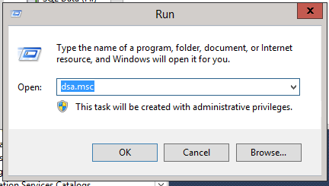

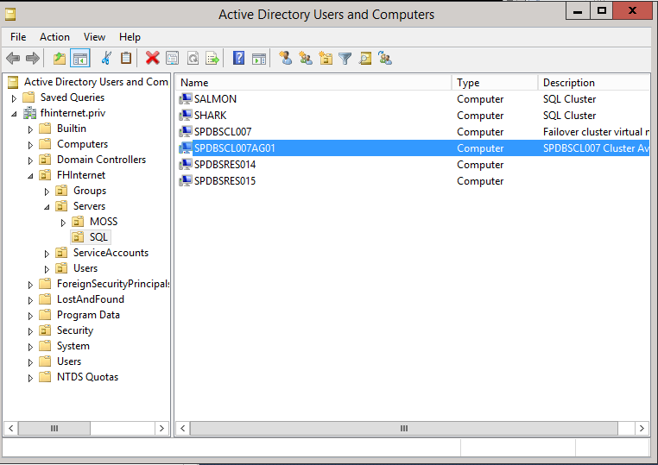

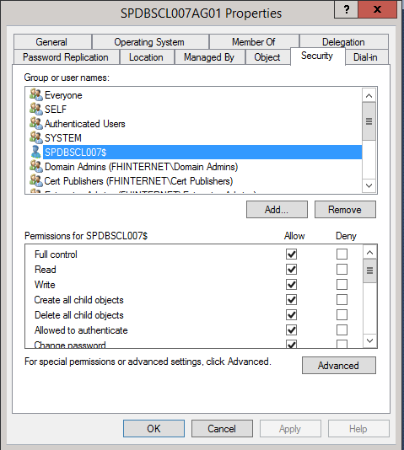

* Or the Cluster Name must be added into one of the following groups:  
  SFHR\AD Join Server to Domain (FHA) - (DE)

PHSABC\AD Join Server to Domain (PHSA) - (DE)  
Healthbc\AD Join Server to Domain (HSSBC) - (DE)

…

* SQL Server Service accounts have read/write access to backup folders

### Failover Clustered Instance:

* Pre-create the SQL Network Name Computer Object and ensure the Cluster Name Account has access. The reason for this is that Cluster Name Account does not have create rights to create the Computer Object during the high availability installation.
* On the listener ensure that the Cluster name account has full control to the Computer Object.
* Create the Service Account for the Instance

## SQL Server Maintenance Setup

High Availability SQL Server nodes use folders on the witness server for SQL Server maintenance. The cluster$ account and each nodes’ service account will require access to these folders.

|  |  |  |  |
| --- | --- | --- | --- |
| **Default Settings** | |  |  |
| **Master database: tbl_maint_parameter** | |  |  |
| ID | | Database_Name | Parameter_Name | Parameter_Value |
| 1 | Default | #full_Backup_Folder | \\WitnessServer\AvailabilityGrpName_SQL_Backup\ServerName\Full\ |
| 2 | Default | #log_Backup_Folder | \\WitnessServer\AvailabilityGrpName_SQL_Backup\ServerName\log\ |
| 61 | Default | #job_output_folder | \\WitnessServer\AvailabilityGrpName_SQL_Backup\serverName\maintenance_job_log\ |
|  |  |  |  |
| **HA Settings** |  |  |  |
| **Master database: tbl_maint_parameter** | |  |  |
| ID | Database_Name | Parameter_Name | Parameter_Value |
| 1 | HA Database Name | #full_Backup_Folder | \\WitnessServer\AvailabilityGrpName_SQL_Backup\AvailibilityGrpName\Full\ |
| 2 | HA Database Name | #log_Backup_Folder | \\WitnessServer\AvailabilityGrpName_SQL_Backup\AvailibilityGrpName\log\ |

# SQL Server 2014 AlwaysOn Setup

## Enable SQL Instance AlwaysOn Availability Groups

On each node of the Windows cluster enable AlwaysOn Availability Groups

1. Open SQL Server Configuration Manager
2. Select the **Properties** for the SQL Server (MSSQLSERVER) service.

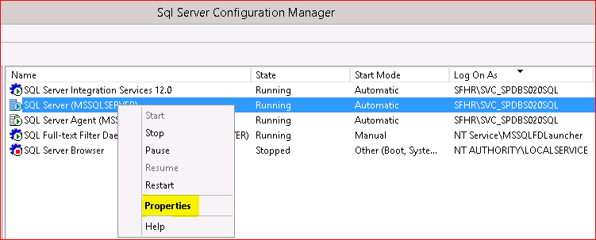

1. On the **AlwaysOn High Availability** Tab, check the Enable check box – This will prompt you to restart the SQL Server service. Select **OK**

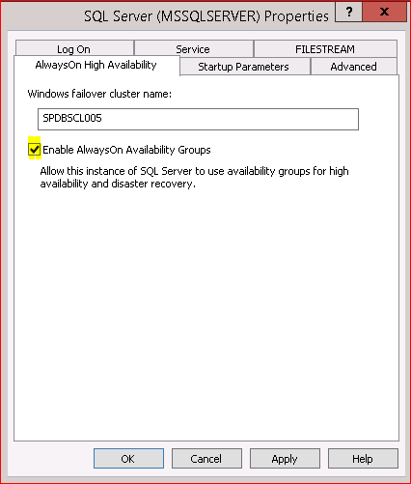

1. Restart the SQL Server service.

## Create New Availability Group

*\*Automatic Failover only works when the Availability Group is NOT installed as an instance in a SQL Cluster. If the Instance is installed into a SQL Cluster the Availability Group will have to be manually failed over.*

Ensure that the database setup prerequisites are complete.

1. Open the **New Availability Group Wizard…** by expanding the SQL Instance explorer and right clicking on **AlwaysOn High Availability**

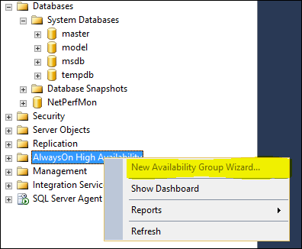

1. Click next to move past the introduction dialog box

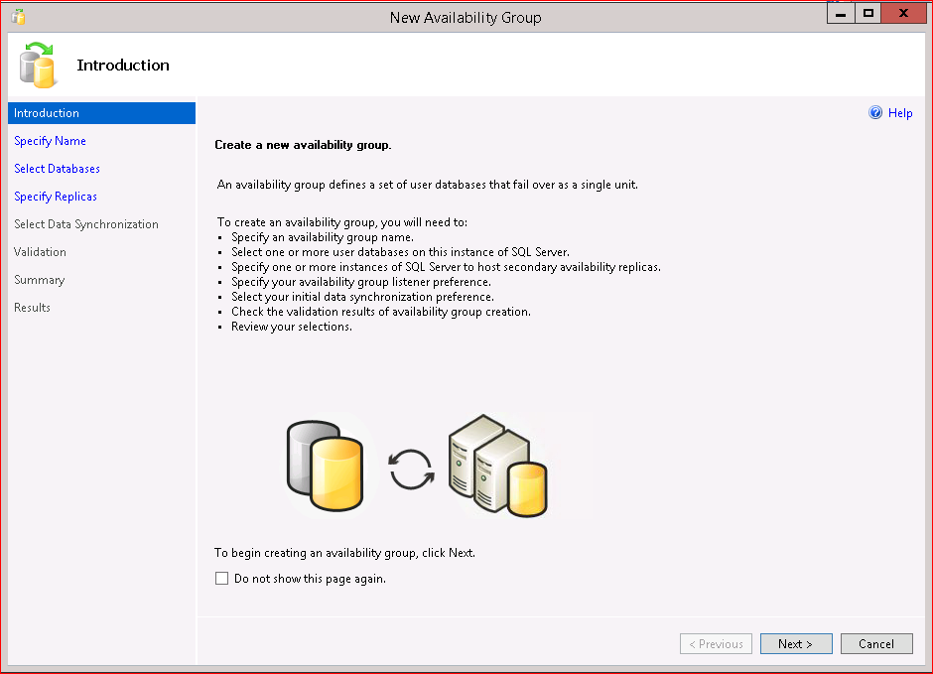

1. Enter the availability group name in the text box of the New Availability Group screen, then click next

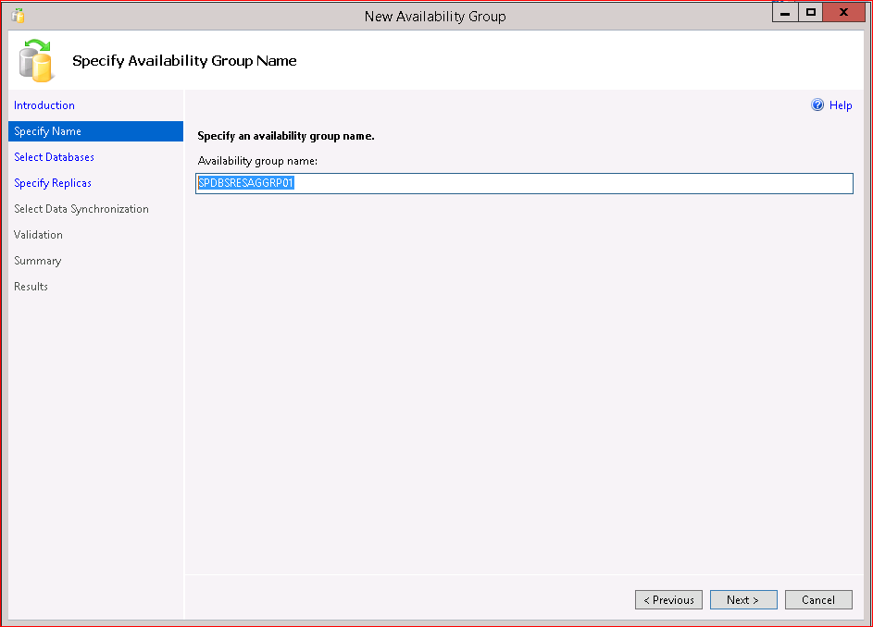

1. Check the databases to be added to the Availability group—click next to proceed

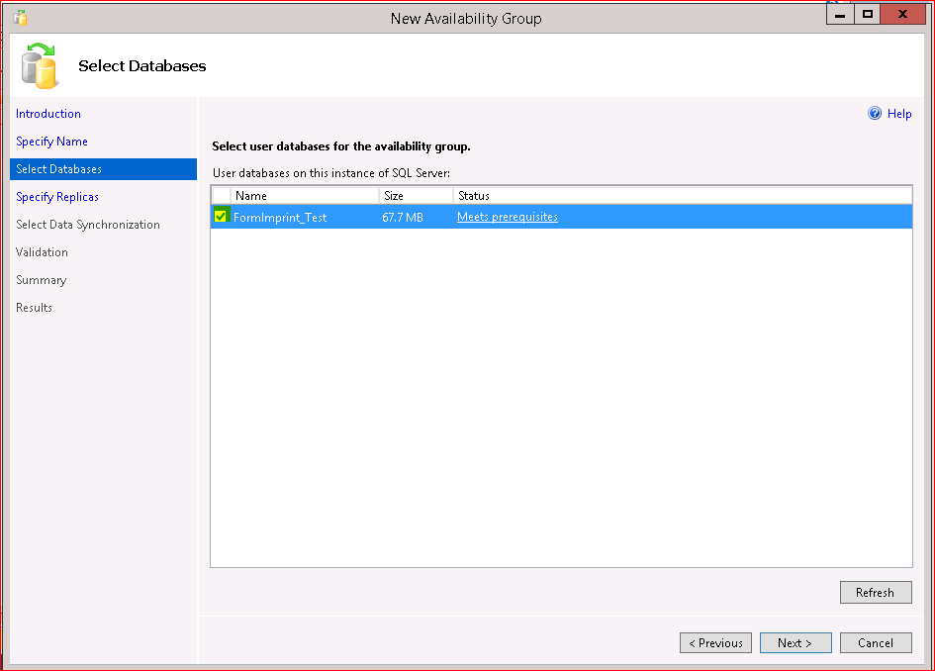

1. Move to the **Specify Replicas** page. The Primary replica appears on the **Replicas** tab of the **Specify Replicas** page. Check **Automatic Failover**, **Synchronous Commit**, and chose ‘Yes’ from **the Readable Secondary** dropdown box—allowing the Secondary Replica to be Readable while not being the active replica.

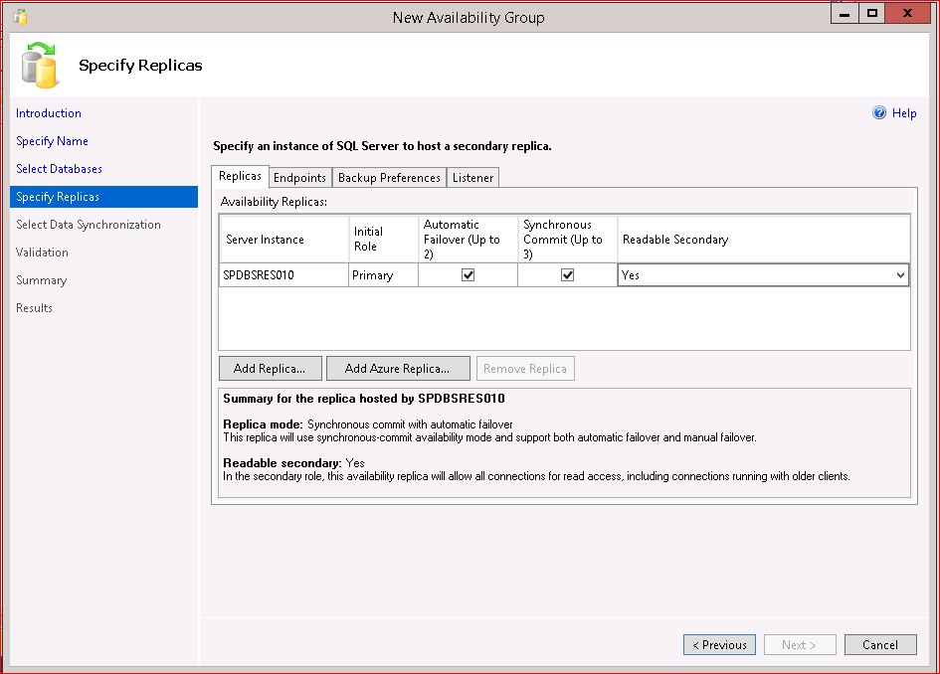

1. Press the **Add Replica…** button.

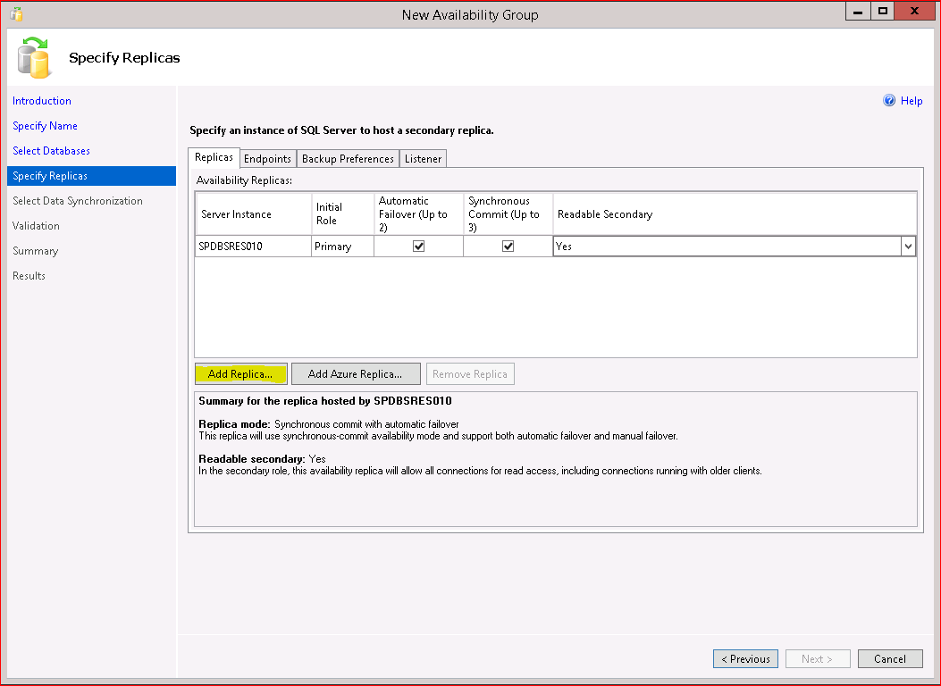

1. Add the **Secondary Replica** to the Availability Group. Enter the Server/Instance and click Connect.

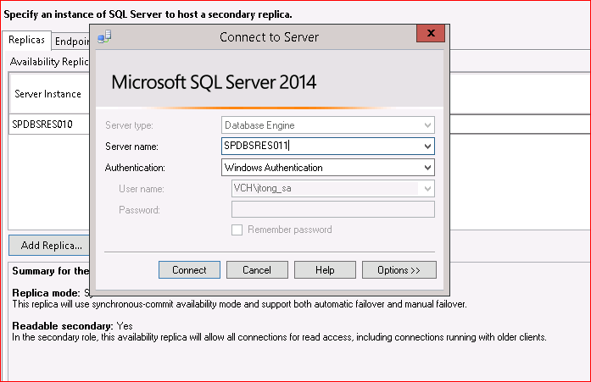

1. Once connected, The **Secondary Replica** will be listed. Make the same selections as before for setting the Automatic Failover, Synchronous Commit, and Readable Secondary. 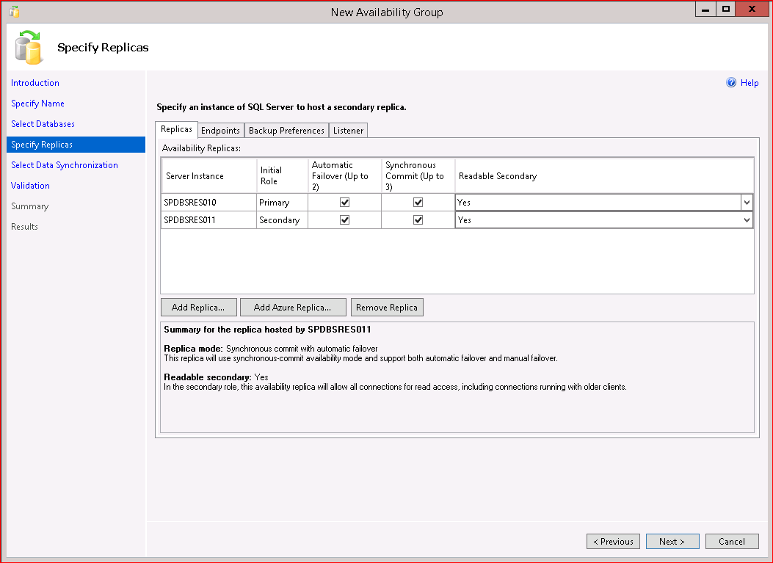
2. Move to the Endpoint Tab. Enter port setting--Endpoints use port 5022. (Typically I put the listener on 5023, 5024, or 5025)

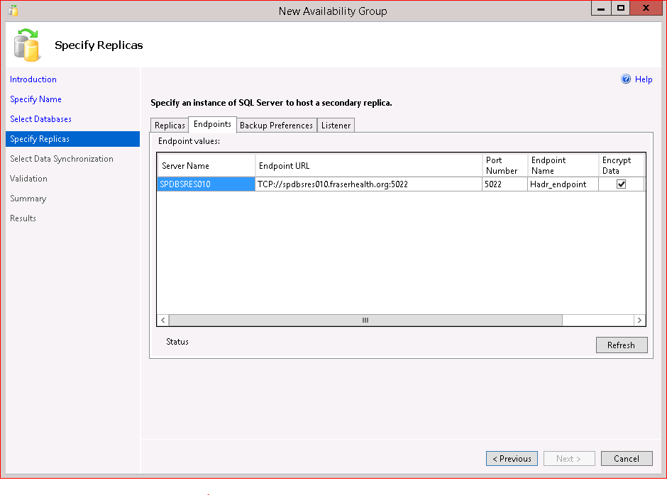

1. Select Backup Preferences tab.

Set the Prefer Secondary as the backup preference for the availability group and use the default Replica backup priorities.

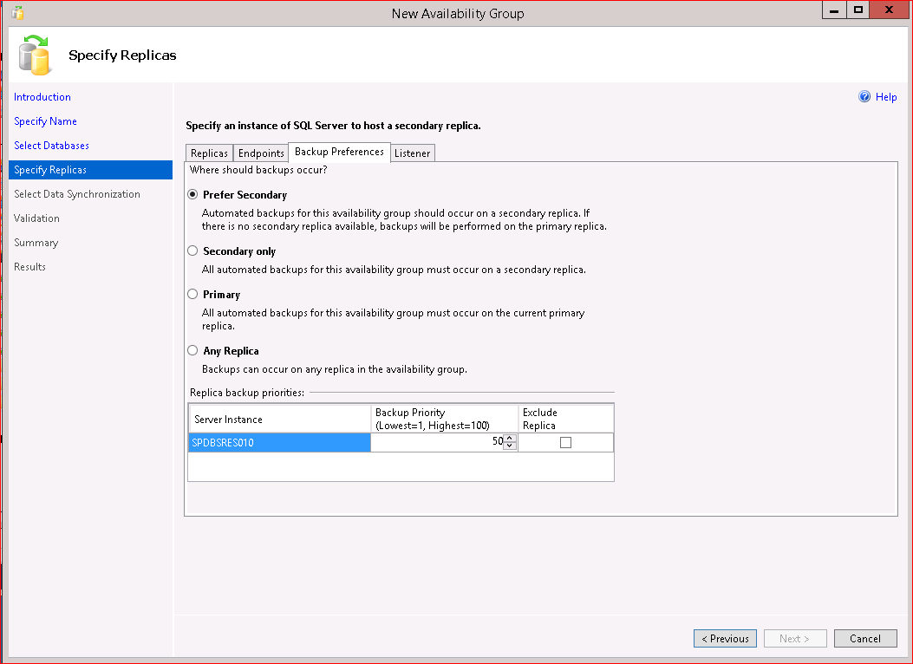

1. On the Listener Tab select “**Create an availability group listener.**” Enter a **Name** in the **Listener DNS Name:** text box. As the name suggests, this will be the name created as a **DNS Host for the Availability group**. This is also the name that will be created as a **Computer Object in the same AD Container as the Server Failover Cluster Name Object**. Enter the Subnet and **IP Address** for use with the Listener Name.

Be certain the Cluster name account, in this case SPDBSCL005$, has full control to the Computer Object.

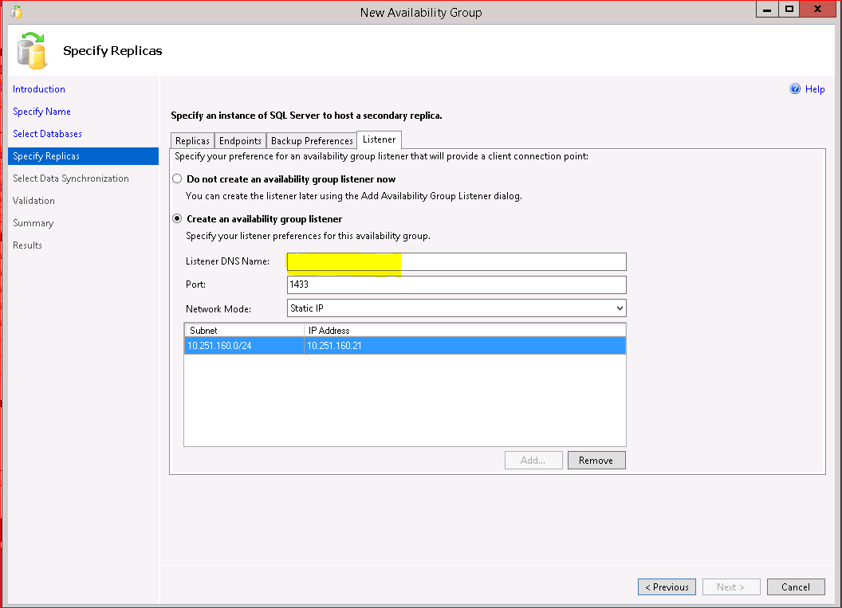

1. Press Next
2. Select OK to complete the Specify replicas page.
3. On the **Select Data Synchronization** page select the **Full** radio button do set the synchronization preference. Enter the UNC Path for the AG Shared Folder that was previously set in Prerequisite step 2.3.3

Choosing the **Full** will result in the wizard creating an initial database backup to the shared folder and then using this backup to restore to the Secondary Replica. This will synchronize the two replicated databases.

A manual synchronization or skipping the initial synchronization may be achieved by selecting **Join only** or **Skip initial data synchronization** options respectively.

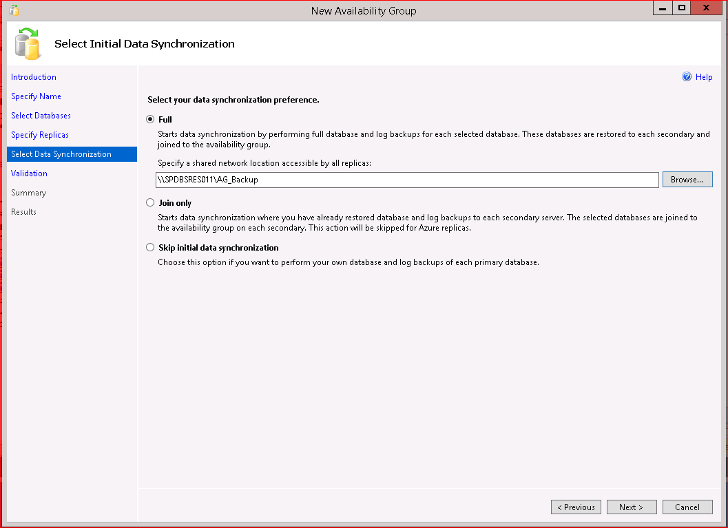

1. By selecting **Next** the wizard will validate the selected options and display the report to the **Validation** Page.

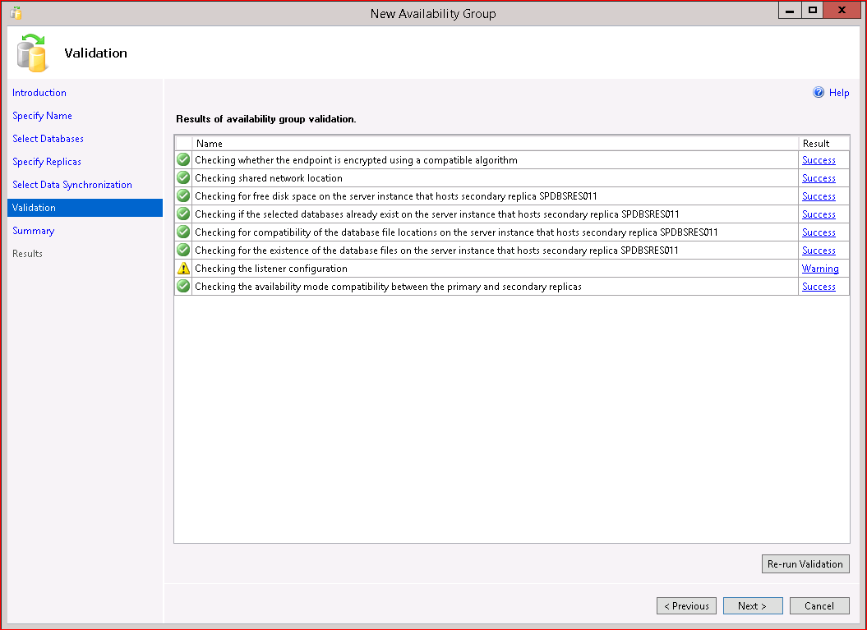

1. Select Next and a Summary of selected options. Verify the settings and click **Finish** to create the **Availability Group**.

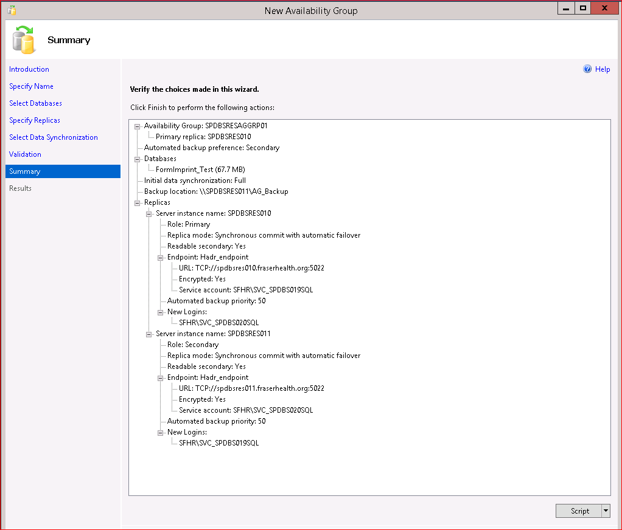

# Troubleshooting

If you receive the following error, check cluster account permissions.

